2200031128 CH BHAVANA
WEEK 7 TASK 3
Create a React Application “eventexamplesapp” to handle various events of the form elements in HTML.

- Create “Increment” button to increase the value of the counter and “Decrement” button to decrease the value of the counter. The “Increase” button should invoke multiple methods.
  - To increment the value
  - Say Hello followed by a static message.

- Create a button “Say Welcome” which invokes the function which takes “welcome” as an argument.
- Create a button which invokes synthetic event “OnPress” which display “I was clicked”
- Create a “CurrencyConvertor” component which will convert the Indian Rupees to Euro when the Convert button is clicked.
- Handle the Click event of the button to invoke the handleSubmit event and handle the conversion of the euro to rupees

- Creating a react app with all the given tasks:

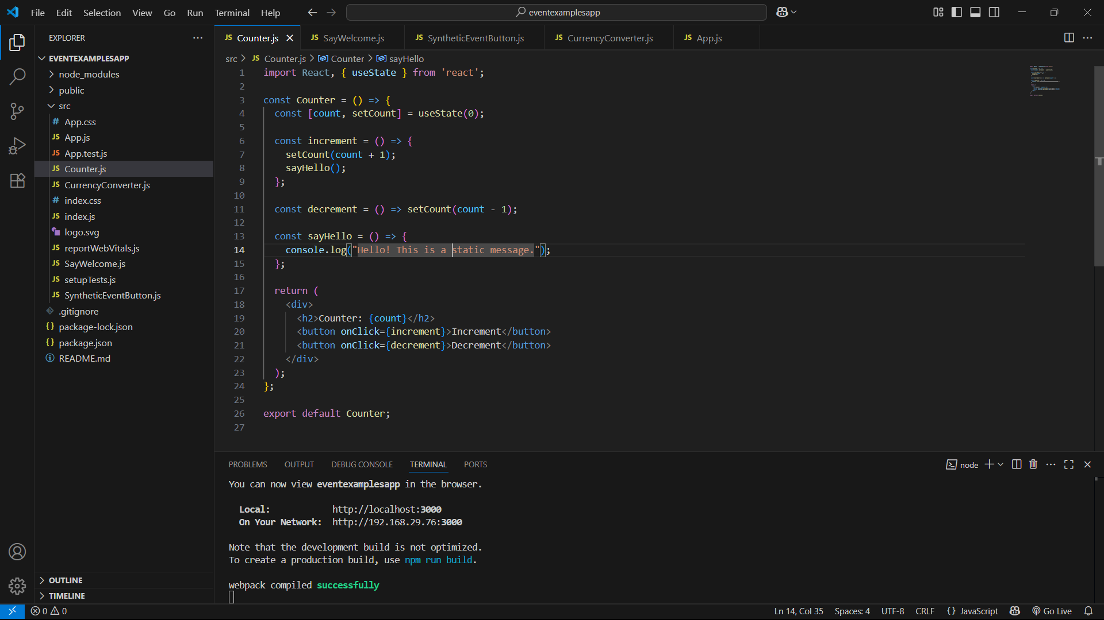
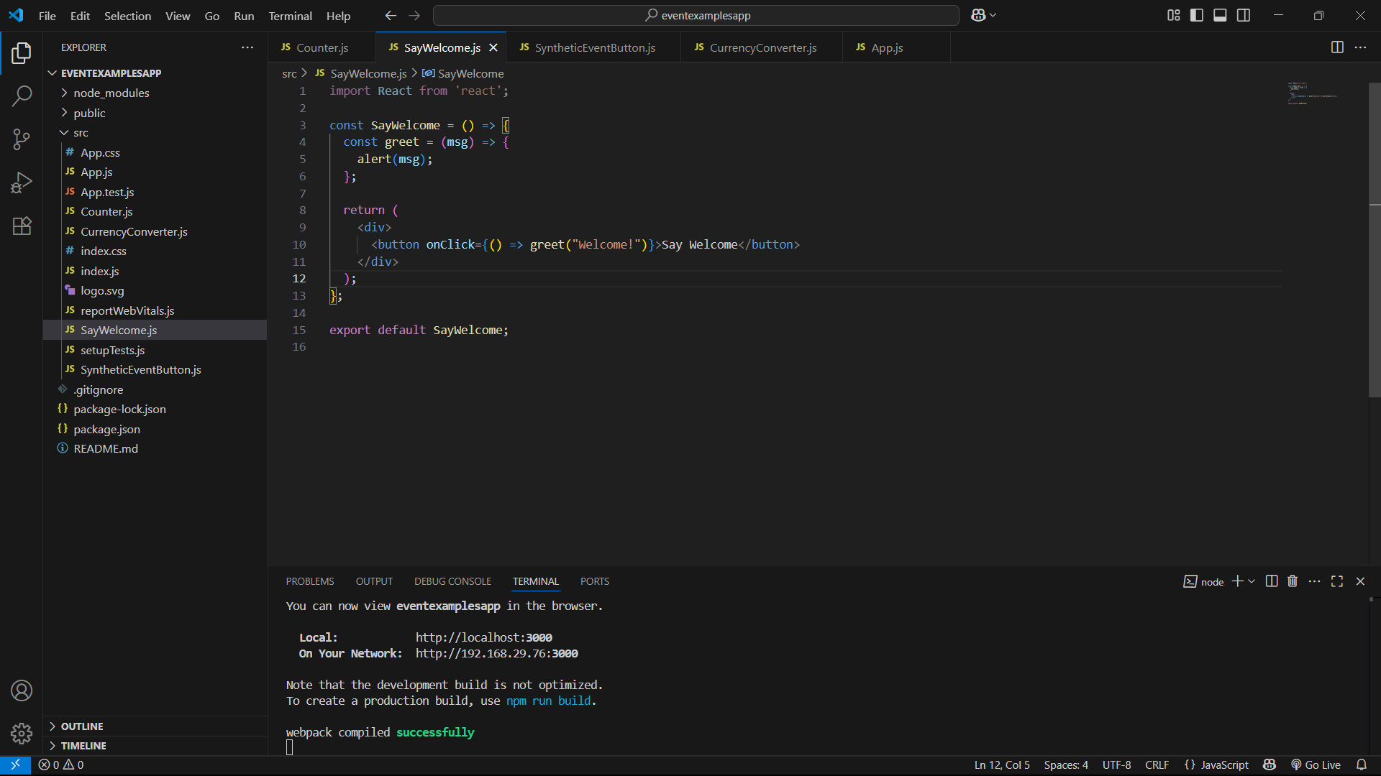
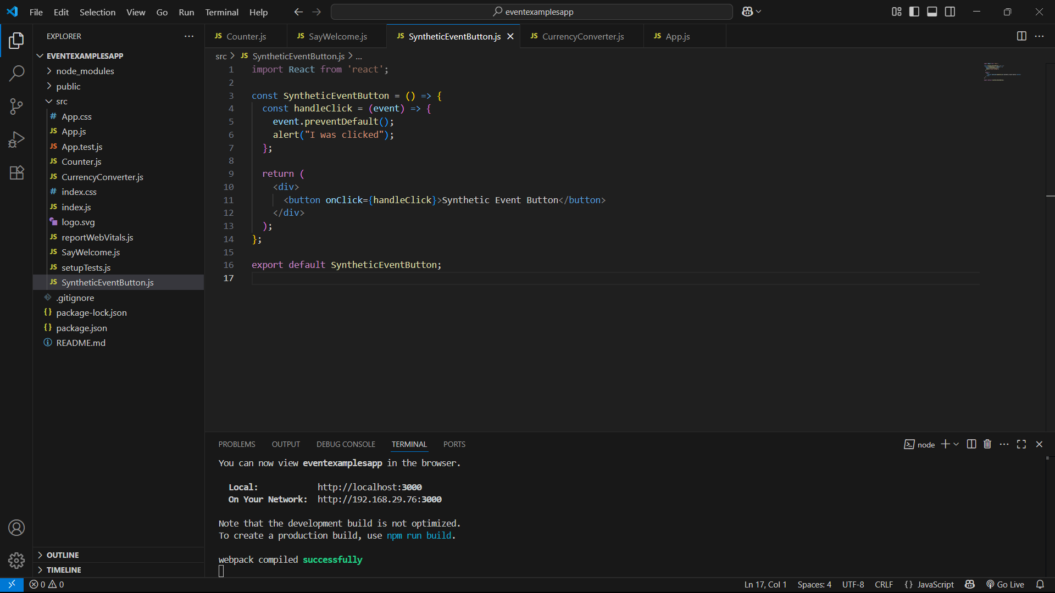
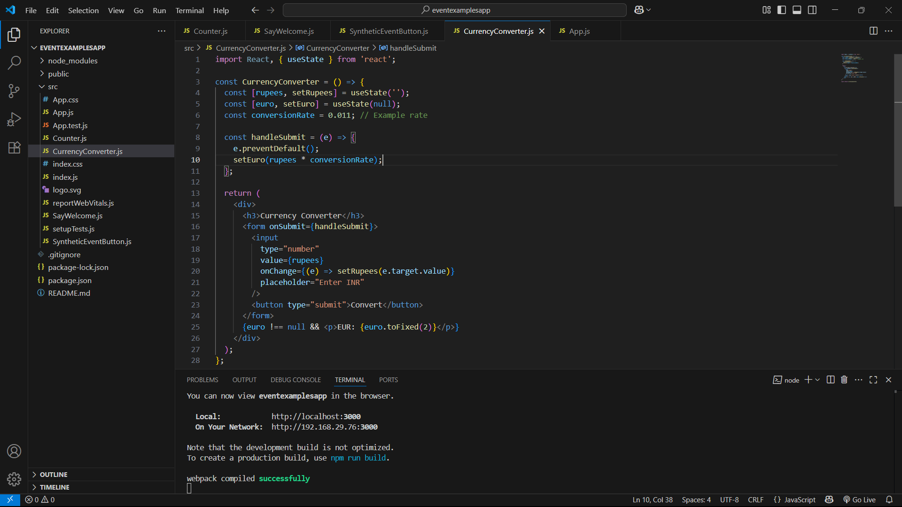
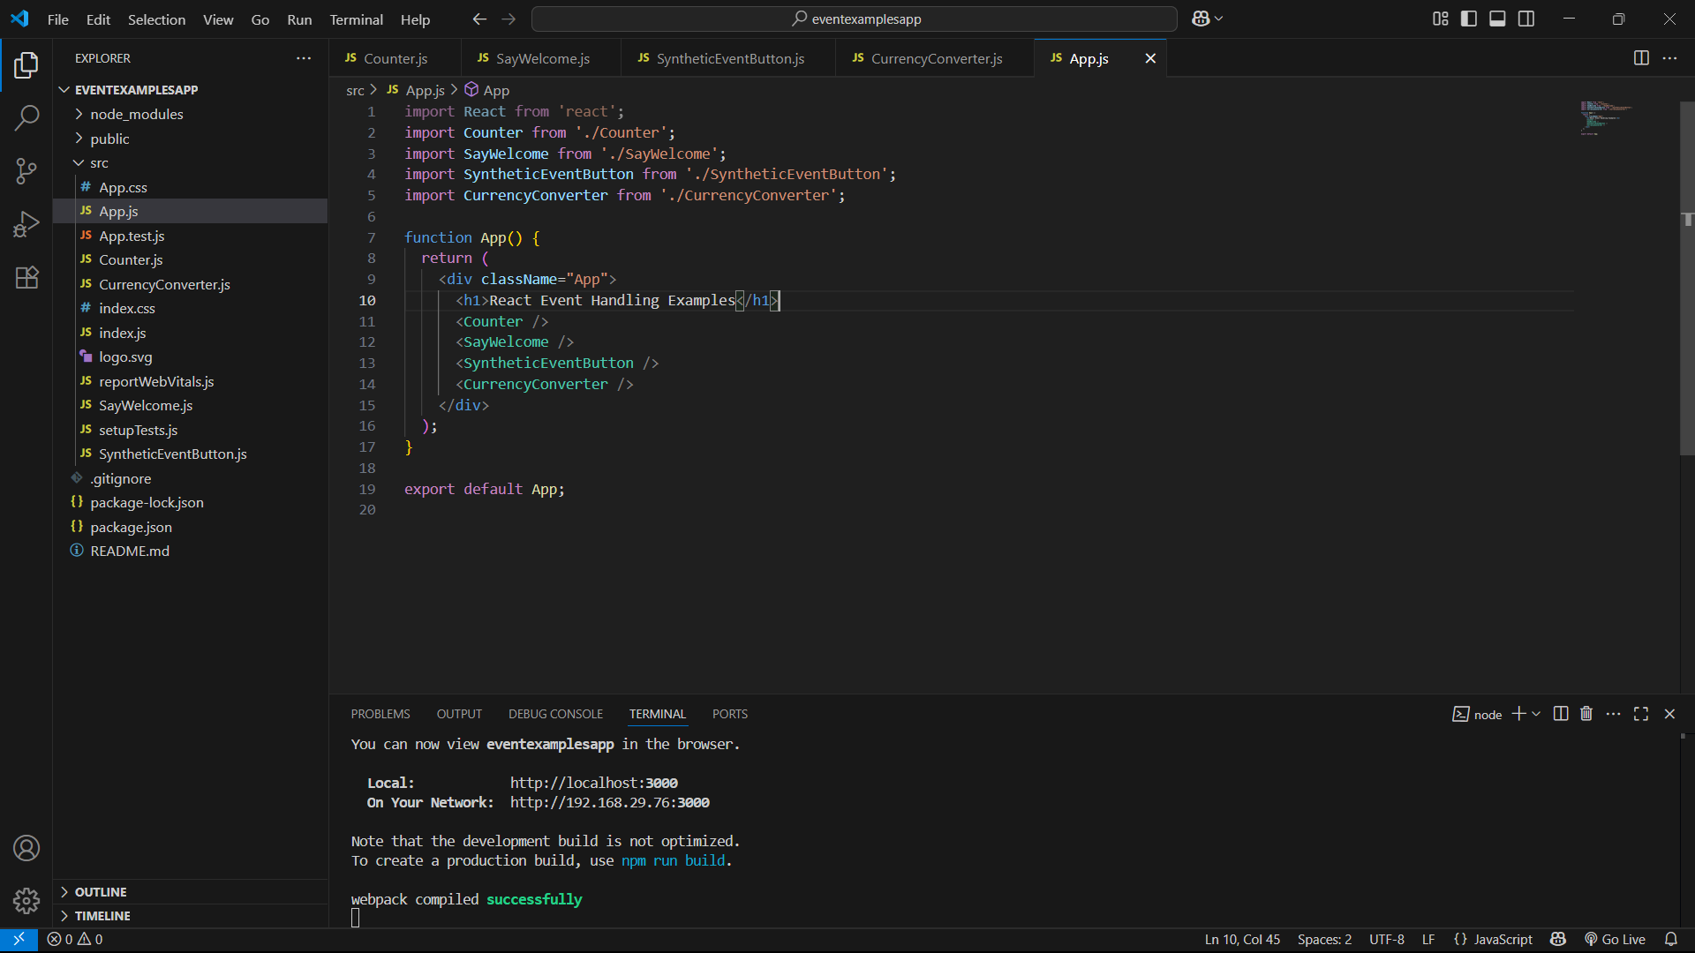

OUTPUTS:
Increment and decrement
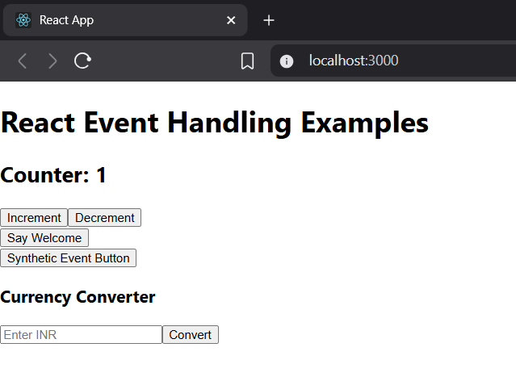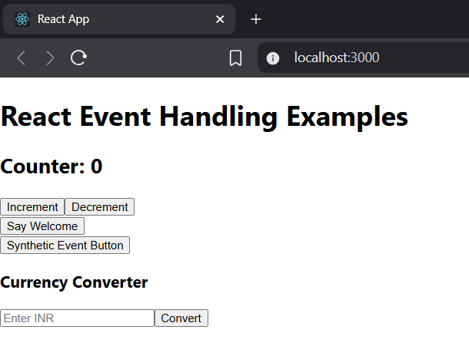
Welcome
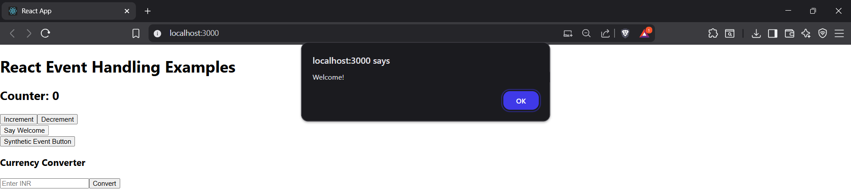
Button
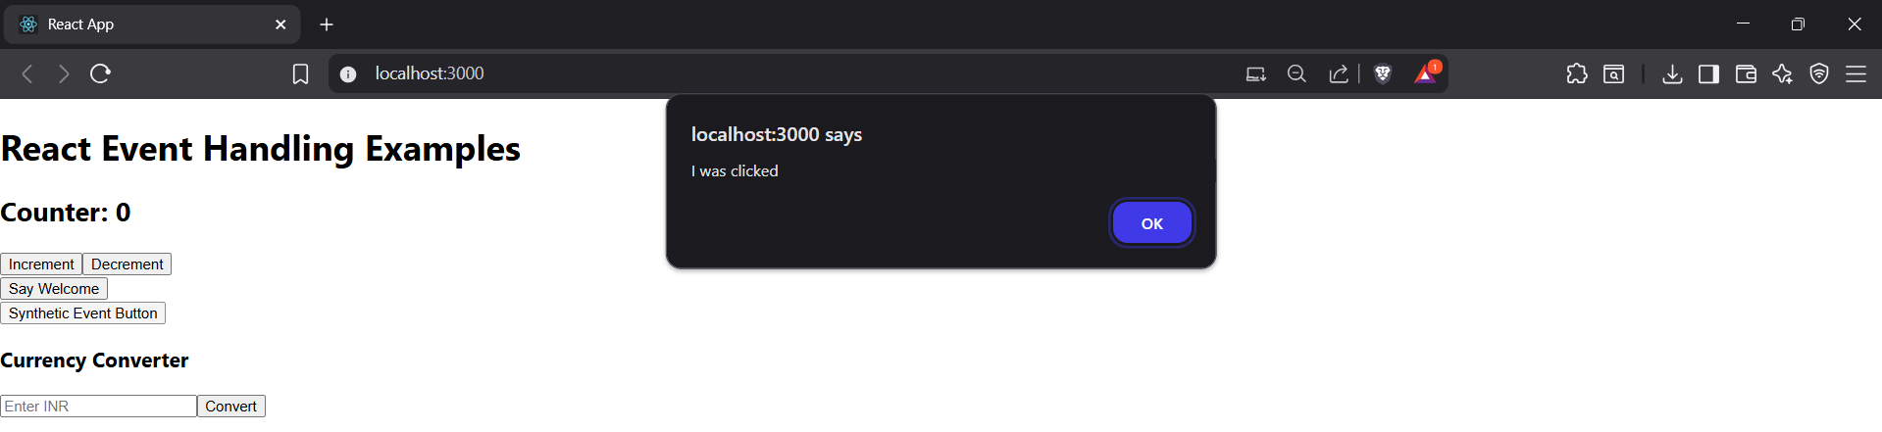
Currency convert
